Software Design Document
Online Election voting website for the university teacher



Submitted by NIMRA RAFEEQ F22BINFT1M01033

Submitted to
MUZAMMIL UR REHMAN

Department of Information Technology Faculty of Computing

The Islamia University of Bahawalpur

Summery

This Software Design Document (SDD) describes the system design of the Online Election Website for University Teachers. The purpose of this system is to automate and digitize the election process conducted for university teachers, ensuring transparency, accuracy, and security.
Traditionally, university elections are conducted manually, which may result in delays, human errors, and lack of proper record management. This online system allows teachers to securely cast their votes through a web-based platform. Administrators can manage candidates, voters, and election schedules efficiently.
The document explains the application architecture, system modules, data model schema, and user interface design. It also highlights the design considerations and technologies used to ensure reliability, usability, and scalability of the system.

Table of Content

- Summary
- Application Architecture
- Data model schema
- User Interface

Application Architecture

The Online Election Website follows a Model–View–Controller (MVC) architecture to ensure separation of concerns, easy maintenance, and scalability.
  - Model: Handles database interaction and business logic.
  - View: Responsible for user interface and presentation.
  - Controller: Manages user requests, processes data, and communicates between Model and View.

This architecture allows for secure handling of voting data while keeping the system modular and manageable.

Authentication Controller

Handles user registration, login, and logout.
  - Validate credentials
  - Encrypt passwords
  - Manage session handling

User Management Controller

Responsible for user approval and profile management.
  - Approve or reject users
  - Manage teacher and admin accounts

Election Controller

Manages election-related operations.
  - Create and schedule elections
  - Activate or deactivate elections

Candidate Controller

  - Handles candidate records.
  - Add candidate information
  - Edit or remove candidates

Voting controller
  - Responsible for voting process.
  - Display candidates
  - Record votes securely
  - Prevent duplicate voting

Result Controller

  - Handles election results.
  - Count votes automatically
  - Display results after election ends

APIs and Libraries

  - Authentication APIs for login and session handling
  - Password encryption library (e.g., crypt)
  - Frontend libraries such as Bootstrap for responsive design

UML Diagrams (Description)
  - Class Diagram: Shows relationships between User, Admin, Election, Vote, and Candidate.
  - Sequence Diagram: Explains the voting process from login to vote submission.
  - Activity Diagram: Demonstrates election workflow from creation to result in declaration.

┌─────────────┐

│ User Logs In │
└─────────────┘
↓
┌─────────────┐

│ Verify Creds? ├──Yes──┐
└─────────────┘ │

│No │
↓ ↓
┌─────────────┐ ┌─────────────┐

│ │ │ Login Error│
│ Select Election│ └─────────────┘
│ │ ↑
└─────────────┘ │
↓ │
┌─────────────┐ │

│ Display Candidates│ │

└─────────────┘ │
↓ │
┌─────────────┐ │

│ Cast Vote │ │
└─────────────┘ │
↓ │
┌─────────────┐ │

│ Confirm Submission│ │
└─────────────┘ │
↓ │
┌─────────────┐ │

│ Vote Recorded │ │
└─────────────┘ │
↓ │
┌─────────────┐ │

│ End Process │<──┘
└─────────────┘

Coding Conventions

  - Meaningful variable and function names
  - MVC-based folder structure
  - Proper indentation and comments Secure coding practices

Data Model Schema

The database is designed using a relational model to ensure data consistency and integrity.

Entities and Description

User (Teacher)

  - UserID (Primary Key)
  - Name

  - Email
  - Password
  - Department
  - Status

Admin

  - AdminID (Primary Key)
  - Username
  - Password

Candidate

  - CandidateID (Primary Key)
  - Name
  - Department
  - Election

Election

  - ElectionID (Primary Key)
  - Title
  - Start Date
  - End Date
  - Status

Vote

  - VoteID (Primary Key)
  - UserID (Foreign Key)
  - CandidateID (Foreign Key)
  - ElectionID (Foreign Key)

Entity Relationships

  - One Election has many Candidates
  - One User can cast only one vote per election
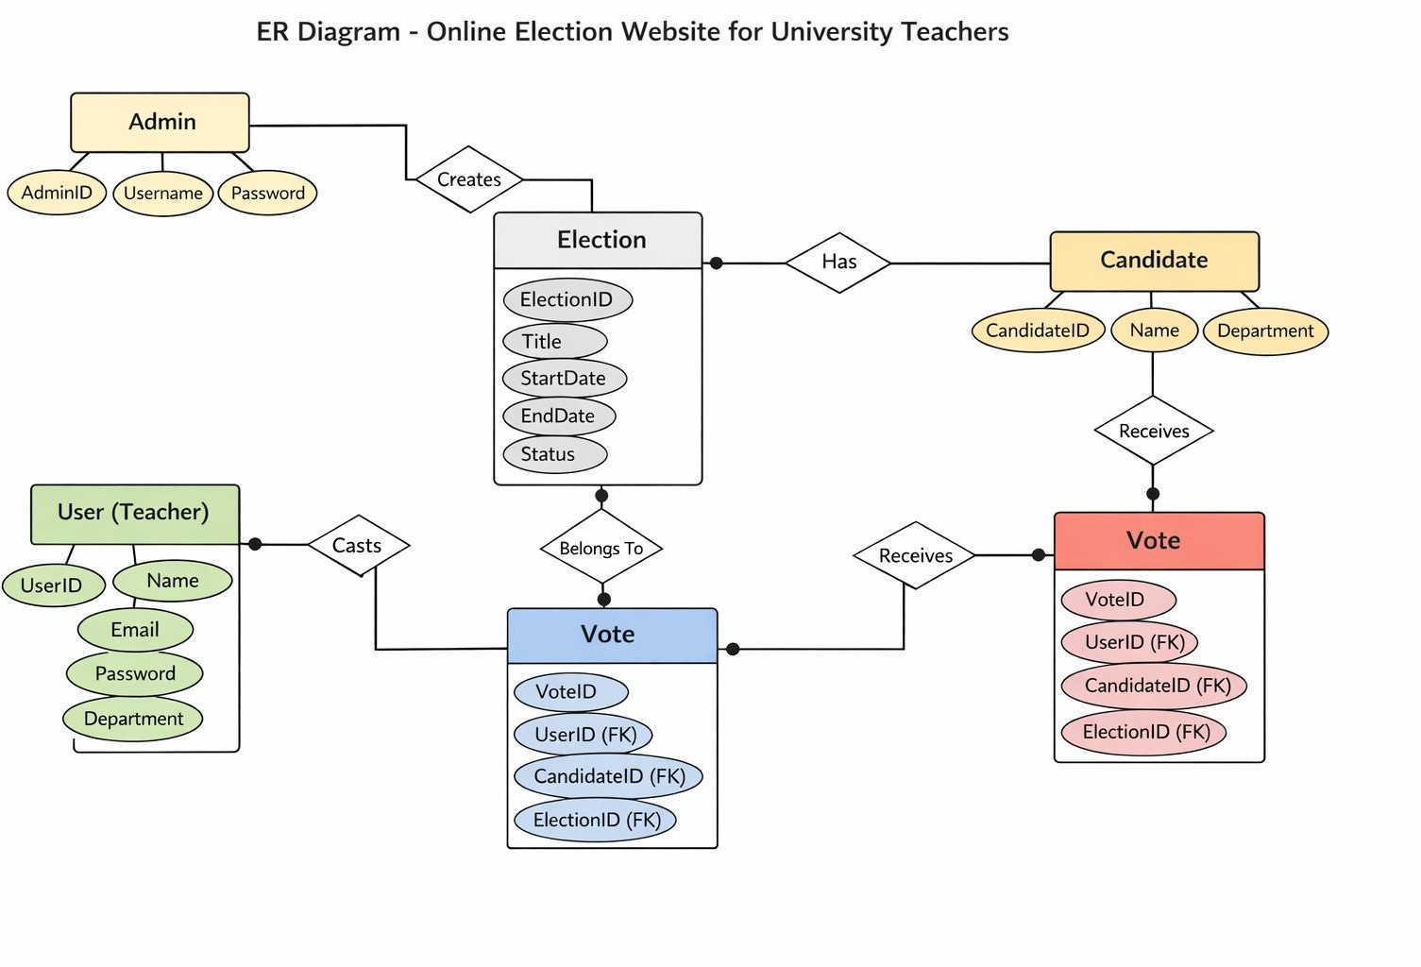
  - Each Vote is linked to one Candidate and one Election

. User Interface

Design Philosophy

  - Simple and clean interface
  - University-themed color scheme
  - Responsive design for desktop and mobile
  - Easy navigation and accessibility

List of Screens / Pages

Login Page

  - Textboxes: Email, Password
  - Button: Login
  - Input validation for credentials

Admin Dashboard

  - Manage elections
  - Manage candidates
  - View results

Teacher Dashboard

  - View ongoing elections
  - Cast vote
  - View confirmation message

Voting Page

  - Candidate list (Radio buttons)
  - Submit Vote button
  - Vote confirmation alert

Results Page

  - Election results in table or chart format

Input Constraints

  - Email must be valid
  - Password must be encrypted
  - One vote per user per election
  - Mandatory field validation

